TRACK RECORD
Victorian transport services quarterly performance bulletin
ISSUE 67 – SERVICES APRIL TO JUNE 2016
Established in April 2012, Public Transport Victoria (PTV) manages Victoria’s train, tram and bus services. PTV also provides a single contact point for customers wanting information on public transport timetables, services, tickets and improvement projects.
Public transport performance improved in the second quarter of 2016, with punctuality and reliability results increasing across metropolitan and regional train services.
There was a small decline in punctuality for metropolitan buses as a reflection of revised measurement systems for tracking bus performance.
Overall satisfaction with metropolitan services decreased compared with last quarter, from 69.0 per cent to 67.3 per cent. There was no change compared to the June 2015 quarter (67.3 per cent).

Contents

TRACK RECORD 1
Contents 4
Punctuality and reliability 5
Punctuality 5
Reliability 8
Quarterly City and Westona Loop Bypasses 9
Unplanned express services 9
Customer compensation 10
Metropolitan train and tram 11
V/Line 12
Bus 12
Customer satisfaction 13
Customer satisfaction 13
About customer satisfaction ratings 13
Overall satisfaction 14
Metropolitan trains 17
Metropolitan trams 18
Metropolitan buses 19
V/Line modes 20
V/Line trains 21
V/Line coaches 22
Travel behaviour and ticketing 23
Travel behaviour 23
myki device availability 24
Fare evasion 25
Attitudes toward Authorised Officers 25
Customer service 26
Website 26
Call Centre 28
Industry-wide feedback 30
About industry feedback 30
Stakeholder share 30
Industry feedback 32
PTV feedback 33

Punctuality and reliability

Punctuality
Metropolitan trains are considered on time if they arrive no more than four minutes and 59 seconds after their scheduled time in the timetable.
Metropolitan trams are considered on time if they arrive no more than 59 seconds before or four minutes and 59 seconds after the scheduled time in the timetable.
Metropolitan buses are considered on time if they arrive no more than 59 seconds before or five minutes and 59 seconds after their scheduled time in the timetable.
Long distance regional trains are considered on time if they arrive no more than 10 minutes and 59 seconds after their scheduled time in the timetable.
Short distance regional trains are considered on time if they arrive no more than five minutes and 59 seconds after their scheduled time in the timetable.
Punctuality measures do not include replacement services (i.e. replacement buses and coaches) which operated during the V/Line restoration period (January – June 2016).
Note: Effective from Track Record 67, punctuality measures for metropolitan bus services have changed.
As of 1 April 2016, punctuality is measured as the proportion of services departing timing points no more than 59 seconds early and no more than 4 minutes and 59 seconds later than timetabled/scheduled. Data is collected by Victoria’s bus tracking system (BTS).
BTS systems collect information from global positioning system (GPS) devices on buses, and at approximately 20,000 bus stops across metropolitan Melbourne.
Prior to the introduction of BTS systems, data was collected through manual reporting mechanisms. Services were considered on time when they arrived no later than 5 minutes and 59 seconds late. Manual reporting was based on limited samples of 5–10 per cent of services.
Table 1: Train, tram and bus punctuality – percentage of services on-time
Mode | Threshold | Apr–Jun 2015 | Jul–Sep 2015 | Oct–Dec 2015 | Jan–Mar 2016 | Apr–Jun 2016
Metropolitan trains | 4 minutes, 59 seconds late | 91.5 | 92.8 | 93.0 | 91.6 | 92.4
Metropolitan trams – average over route | 4 minutes, 59 seconds late | 82.7 | 85.0 | 82.3 | 83.7 | 83.9
V/Line trains | punctuality | 88.5 | 87.7 | 87.8 | 81.9 | 88.1
Metropolitan trams – average over route | 4 minutes, 59 seconds late | 72.7 | 76.3 | 72.3 | 74.6 | 74.2
Metropolitan buses – average over route | punctuality | — | 80.0 | 78.5 | 78.6 | 79.4
Metropolitan buses – old measure | punctuality | 93.1 | 89.8 | 90.8 | 89.6 | —

Figure 1: Train, tram and bus punctuality – percentage of services on-time
Table 2: Metropolitan train punctuality – percentage of peak services on-time at destination
Line | Apr – Jun 2015 | Jul – Sep 2015 | Oct – Dec 2015 | Jan – Mar 2016 | Apr – Jun 2016
Alamein | 90.1% | 93.4% | 91.5% | 91.2% | 90.4%
Belgrave | 83.2% | 87.2% | 89.0% | 87.9% | 80.3%
Craigieburn | 89.2% | 91.5% | 90.8% | 90.3% | 91.3%
Cranbourne | 85.5% | 89.4% | 88.5% | 84.8% | 83.9%
Frankston | 87.3% | 89.4% | 88.3% | 86.5% | 93.5%
Glen Waverley | 93.1% | 94.7% | 95.1% | 94.6% | 94.9%
Hurstbridge | 90.8% | 92.2% | 93.1% | 92.1% | 91.9%
Lilydale | 86.6% | 89.0% | 91.3% | 88.5% | 85.4%
Pakenham | 86.7% | 91.0% | 89.8% | 85.9% | 86.0%
Sandringham | 93.5% | 96.8% | 96.8% | 93.6% | 94.1%
South Morang | 93.5% | 95.2% | 95.8% | 96.0% | 94.8%
Stony Point | 87.5% | 96.9% | 96.1% | 92.7% | 94.4%
Sunbury | 91.3% | 92.3% | 92.4% | 88.8% | 91.3%
Upfield | 93.1% | 95.0% | 93.5% | 92.7% | 93.7%
Werribee | 85.4% | 93.0% | 93.2% | 89.4% | 91.0%
Williamstown | 89.9% | 94.9% | 94.6% | 92.0% | 94.3%
Network Total | 89.2% | 92.3% | 92.3% | 90.2% | 90.7%
Table 3: Metropolitan train punctuality – percentage of off-peak services on-time at destination
Line | Apr – Jun 2015 | Jul – Sep 2015 | Oct – Dec 2015 | Jan – Mar 2016 | Apr – Jun 2016
Alamein | 94.2% | 95.2% | 95.6% | 94.0% | 93.7%
Belgrave | 90.5% | 91.7% | 93.1% | 92.4% | 89.3%
Craigieburn | 92.3% | 92.3% | 92.2% | 92.7% | 93.3%
Cranbourne | 88.3% | 89.7% | 88.7% | 87.8% | 88.2%
Frankston | 89.5% | 89.0% | 89.1% | 89.7% | 94.6%
Glen Waverley | 96.4% | 96.1% | 96.4% | 97.2% | 97.7%
Hurstbridge | 95.1% | 95.0% | 95.7% | 93.4% | 94.6%
Lilydale | 91.7% | 93.2% | 94.0% | 91.7% | 90.9%
Pakenham | 89.0% | 88.8% | 88.6% | 86.5% | 86.5%
Sandringham | 95.2% | 95.2% | 95.5% | 94.1% | 95.8%
South Morang | 95.0% | 94.5% | 96.2% | 94.5% | 94.2%
Stony Point | 100.0% | 97.4% | 95.1% | 94.4% | 96.4%
Sunbury | 93.0% | 93.5% | 93.7% | 88.7% | 93.7%
Upfield | 93.8% | 94.5% | 93.5% | 93.4% | 94.8%
Werribee | 92.0% | 93.6% | 94.1% | 92.7% | 94.1%
Williamstown | 95.7% | 96.0% | 95.3% | 94.8% | 95.8%
Network Total | 92.7% | 93.1% | 93.4% | 92.2% | 93.3%

Reliability
Metropolitan train reliability is measured as the percentage of the timetable that is delivered. Non-delivery of services includes cancellations, trains that run short and trains that bypass the City or Altona Loops.
Metropolitan tram reliability is based on the percentage of the timetable delivered. Non-delivery of services includes cancellations and trams that run short.
Metropolitan bus reliability is the percentage of services that operate and are completed.
Regional train reliability is measured as the percentage of scheduled services that are delivered.
Reliability measures do not include replacement services (i.e. replacement buses and coaches) which operated during the V/Line restoration period (January – June 2016).
Table 4: Train and tram reliability – percentage of timetable delivered

Mode | Measure | Apr – Jun 2015 | Jul – Sep 2015 | Oct – Dec 2015 | Jan – Mar 2016 | Apr –Jun 2016
Metropolitan trains | % timetable delivered | 98.6 | 98.9 | 98.8 | 98.3 | 98.8
Metropolitan trams | % timetable delivered | 99.1 | 99.0 | 98.7 | 98.6 | 98.8
V/Line trains | % services delivered | 98.5 | 98.0 | 97.4 | 92.5 | 98.1
Metropolitan buses | % services delivered | >99.9 | >99.9 | >99.9 | >99.9 | >99.9
Figure 2: Train, tram and bus reliability – percentage of timetable delivered

Quarterly City and Westona Loop Bypasses
Table 5: Quarterly City and Westona Loop Bypasses
Line | Q2 2015 | Q3 2015 | Q4 2015 | Q1 2016 | Q2  2016 | Services scheduled to run through the loop Q2 2016
Alamein | 68 | 53 | 49 | 54 | 61 | 1,323
Belgrave | 128 | 129 | 96 | 140 | 108 | 4,185
Craigieburn | 21 | 24 | 36 | 26 | 18 | 6,372
Cranbourne | 171 | 176 | 165 | 246 | 204 | 3,538
Frankston | 148 | 146 | 153 | 157 | 107 | 3,643
Glen Waverley | 51 | 27 | 51 | 55 | 41 | 3,657
Hurstbridge | 10 | 15 | 17 | 35 | 11 | 6,261
Lilydale | 220 | 162 | 151 | 195 | 166 | 6,623
Pakenham | 226 | 234 | 215 | 247 | 204 | 6,547
Sandringham | 17 | 27 | 34 | 33 | 24 | 1,404
South Morang | 12 | 25 | 14 | 34 | 13 | 5,826
Sunbury | 13 | 18 | 40 | 20 | 14 | 6,387
Upfield | 11 | 15 | 22 | 20 | 12 | 4,689
Werribee (Delivered Bypassing City Loop) | 10 | 1 | 14 | 6 | 7 | 41
Werribee (Delivered Bypassing Westona Loop) | 122 | 74 | 110 | 79 | 72 | 8,458
Werribee (Delivered Bypassing Both Loops) | 1 | – | – | 1 |  | 1,202
Grand Total | 1,229 | 1,126 | 1,167 | 1,348 | 1,062 | 70,156

There were 1062 bypasses of the City Loop this quarter, which is 1.5 per cent of the 68,954 services scheduled to run through the loop during this time.
There were 72 bypasses of the Westona Loop, which is 0.8 per cent of the 8,458 services scheduled to run through the loop during this time.

Unplanned express services
Table 6: Quarterly unplanned express services
Measure | Apr – Jun 2015 | Jul – Sep 2015 | Oct – Dec 2015 | Jan – Mar 2016 | Apr – Jun 2016
Total number of timetabled services | 185,846 | 192,101 | 188,832 | 190,166 | 192,284
Number of express run services | 190 | 82 | 75 | 107 | 46
Percentage of total services run as unplanned express | 0.1 | 0.0 | 0.0 | 0.1 | 0.0
The percentage of services run as unplanned express over the June 2016 quarter was 0.02 per cent.

Customer compensation
Train and tram operators are expected to deliver a punctual and reliable service for customers.
PTV insists that operators do everything they can to deliver services in line with the agreed timetable.
Where operators fall short, they are required to pay compensation to customers, in the form of complimentary travel. Only customers who travel with a periodical ticket of four weeks or more are eligible to receive compensation.
Table 7: Service level thresholds for compensation (per cent)
Measure | Threshold | Trains | Trams | V/Line
Punctuality | Arrival by 4 minutes, 59 seconds | 88 | 77 | -
 | Arrival by 5 minutes, 59 seconds | - | - | 92*
Reliability | Percentage of timetable delivered | 98 | 98 | -
 | Percentage of services delivered | - | - | 96
* For long distance V/Line services, on-time arrival is defined as arriving no later than 10 minutes and 59 seconds after the timetabled arrival time
Metropolitan trains
Customer compensation was not paid for metropolitan trains this quarter.
Metropolitan trams
Customer compensation was not paid for metropolitan trams this quarter.
V/Line
In April, Passenger compensation is payable on all lines except Ararat & Maryborough, Seymour, Shepparton and Swan Hill & Echuca as punctuality was below the applicable threshold (92.0 per cent).
In May, passenger compensation is payable on all lines except Albury, Shepparton and Swan Hill & Echuca as punctuality was below the applicable threshold (92.0 per cent).
In June passenger compensation is payable on all lines except Ararat & Maryborough, Shepparton and Swan Hill & Echuca as punctuality was below the applicable threshold (92.0 per cent).
Note: Despite V/Line meeting reliability targets on all lines in June 2016, customer compensation has been made available to all customers travelling on replacement coaches from 8 February to 26 June.
Payments

Metropolitan train and tram
Metro Trains and Yarra Trams receive regular payments from Public Transport Victoria to cover the delivery of services and the operation and development of the networks. The terms of these payments are outlined in operator franchise agreements.
PTV requires that operators meet agreed performance targets. Penalties or incentives are paid depending on how operators perform against these targets.
Incentive payments are based on a detailed measure of the passenger impact of service disruptions. These include delays, cancellations, short services and a number of other disruption types (including trains that bypass the City and/or Westona loops).
Each disruption is multiplied by an agreed 'passenger weighting' for that service which depends on the route, the time of day, and the direction of the service. Longer delays result in higher penalties. Operators can receive bonus payments or incur penalties depending on whether the level of disruption is above or below agreed levels in the contracts.
Table 8: Metropolitan train payments ($'000s)
Payment type | Apr – Jun 2015 | Jul – Sep 2015 | Oct – Dec 2015 | Jan – Mar 2016 | Apr – Jun 2016
Base contract | 63,799 | 50,989 | 62,078 | 49,384 | 59,471
Incentive or penalty | 3,405 | 3,295 | 3,457 | 531 | 2,310
Customer Experience Performance Regime | 0 | 0 | 200 | 0 | 0
Revenue Reset Adjustment Payment | 24,593 | 19,492 | 17,864 | 28,954 | 28,954
Maintenance and projects¹ | 80,059 | 102,425 | 76,490 | 68,278 | 64,213
Rolling stock² | 23,899 | 27,852 | 24,315 | 23,220 | 19,688
Operations and systems³ | 15,543 | 18,775 | 11,408 | 13,049 | 12,233
TOTAL | 211,298 | 222,828 | 195,612 | 183,416 | 186,868
¹ Maintenance and projects combines maintenance and capital projects payments
² Rolling stock payments include rolling stock adjustments and exams
³ Operations and systems include payments for business system upgrades, driver establishment, electricity, and employee entitlements
Table 9: Metropolitan tram payments ($'000s)
Payment type | Apr – Jun 2015 | Jul – Sep 2015 | Oct – Dec 2015 | Jan – Mar 2016 | Apr – Jun 2016
Base contract | 7,313 | 3,494 | 5,903 | 2,986 | 480
Incentive and penalty | -788 | -89 | -1,619 | -1,226 | -1,341
Customer Experience Performance Regime | 0 | 0 | 439 | 0 | 0
Revenue Reset Adjustment Payment | 12,814 | 19,619 | 19,619 | 16,377 | 17,859
Maintenance and projects¹ | 15,065 | 16,349 | 17,522 | 15,065 | 24,549
Rolling stock | 8,767 | 8,767 | 8,767 | 8,767 | 8,767
Operations and systems² | 3,206 | 3,596 | 4,692 | 3,772 | 3,104
TOTAL | 46,377 | 51,736 | 55,324 | 45,741 | 53,418
¹ Maintenance and projects combines maintenance and capital projects payments
² Operations and systems payments include business system upgrades, electricity and employee entitlements

V/Line
Regional coach payments are made to V/Line, which is a state-owned enterprise, however regional train payments and penalties have ceased following the signing of the V/Line services agreement.
Table 10: Regional train and coach payments ($'000s)
Payment type | Apr – Jun 2015 | Jul – Sep 2015 | Oct – Dec 2015 | Jan – Mar 2016 | Apr – Jun 2016
Base contract | 81,936 | 78,570 | 87,057 | 82,866 | 129,836
Regional Coaches | 8,212 | 8,573 | 8,573 | 8,573 | 8,573
Farebox | 22,442 | 22,698 | 20,919 | 21,671 | 21,508
Rolling stock | 8,953 | 8,953 | 8,953 | 8,953 | 8,953
Total | 121,543 | 118,794 | 125,502 | 122,063 | 168,870

Bus
PTV has individual contracts with bus operators to run services in Melbourne and regional areas. Payments are made to these operators to help deliver route and school bus services.
Table 11: Metropolitan, regional and school bus payments ($'000s)
Payment type | Apr – Jun 2015 | Jul – Sep 2015 | Oct – Dec 2015 | Jan – Mar 2016 | Apr – Jun 2016
Metropolitan | 144,650 | 144,852 | 146,536 | 144,751 | 146,975
Regional | 27,256 | 27,534 | 27,332 | 28,951 | 29,114
School | 55,357 | 56,144 | 56,214 | 37,287 | 56,113
Total | 227,263 | 228,530 | 230,081 | 210,989 | 232,201

Customer satisfaction

Customer satisfaction
Overall satisfaction with metropolitan services decreased compared with last quarter, from 69.0 per cent to 67.3 per cent. There was no significant change compared to the June 2015 quarter (67.3 per cent).
Overall satisfaction with metropolitan trains decreased compared with last quarter, at 70.9 per cent. This result also reflected an overall decrease compared to the June 2015 quarter (71.2 per cent). Compared with last quarter, there was a significant decrease in customer satisfaction with comfort, myki ticketing, staff service, safety and a significant decrease in the likelihood to recommend.
Overall satisfaction with metropolitan trams decreased compared with last quarter, from 76.3 per cent to 75.2 per cent. The result remained the same as the June 2015 quarter (75.2 per cent). Compared with last quarter, there was a significant decrease in customer satisfaction with safety and in the likelihood to recommend.
Overall satisfaction with metropolitan buses decreased slightly compared with last quarter, from 77.7 per cent to 76.0 per cent. The result was also a decrease compared to the June 2015 quarter (76.6 per cent). Compared with last quarter, there was a significant decrease in customer satisfaction with service delivery.

Overall customer satisfaction with regional trains increased slightly compared with last quarter, from 73.8 per cent to 74.5 per cent. This was also a decrease compared to the June 2015 quarter (76.9 per cent). Compared with last quarter, there was a significant decrease in customer satisfaction with stations and stops. Compared with the June 2015 quarter, there was a significant decrease in satisfaction with information provided, comfort and likelihood to recommend however there was an increase in satisfaction with ticketing.
Overall customer satisfaction with regional coaches decreased slightly compared with last quarter, from 86.6 per cent to 78.4 per cent. The result was also a decrease compared to the June 2015 quarter (85.7 per cent).

About customer satisfaction ratings
All results except overall metropolitan satisfaction (six-point scale) are reported in a 0-10 scale. Results prior to April 2009 were reported on a six-point scale.

Overall satisfaction
Table 12: Metropolitan public transport modes overall satisfaction
Apr – Jun 2014 | Jul – Sep 2014 | Oct – Dec 2014 | Jan – Mar 2015 | Apr – Jun 2015 | Jul – Sep 2015 | Oct – Dec 2015 | Jan – Mar 2016 | Apr – Jun 2016
66.1 | 66.4 | 66.7 | 68.1 | 67.3 | 67.8 | 69.6 | 69.0 | 67.3
Note: These results are still presented in the six-point scale.
Figure 3: Metropolitan public transport modes overall satisfaction

Table 13a: Metropolitan trains individual overall satisfaction
Mode | Apr – Jun 2014 | Jul – Sep 2014 | Oct – Dec 2014 | Jan – Mar 2015 | Apr – Jun 2015 | Jul – Sep 2015 | Oct – Dec 2015 | Jan – Mar 2016 | Apr – Jun 2016
Metropolitan Trains | 70.4 | 71.4 | 71.5 | 71.9 | 71.2 | 71.4 | 73.5 | 73.5 | 70.9

Figure 4a: Metropolitan trains individual overall satisfaction

Table 13b: Metropolitan trams individual overall satisfaction
Mode | Apr – Jun 2014 | Jul – Sep 2014 | Oct – Dec 2014 | Jan – Mar 2015 | Apr – Jun 2015 | Jul – Sep 2015 | Oct – Dec 2015 | Jan – Mar 2016 | Apr – Jun  2016
Metropolitan Trams | 74.4 | 73.7 | 74.7 | 75.9 | 75.2 | 75.6 | 77.1 | 76.3 | 75.2

Figure 4b: Metropolitan trams individual overall satisfaction

Table 13c: Metropolitan buses individual overall satisfaction
Mode | Apr – Jun 2014 | Jul – Sep 2014 | Oct – Dec 2014 | Jan – Mar 2015 | Apr – Jun 2015 | Jul – Sep 2015 | Oct – Dec 2015 | Jan – Mar 2016 | Apr – Jun 2016
Metropolitan Buses | 76.2 | 76.2 | 75.2 | 76.5 | 76.6 | 76.9 | 76.1 | 77.7 | 76.0

Figure 4c: Metropolitan buses individual overall satisfaction

Metropolitan trains
Figure 5a: Satisfaction with key service aspects for metropolitan trains
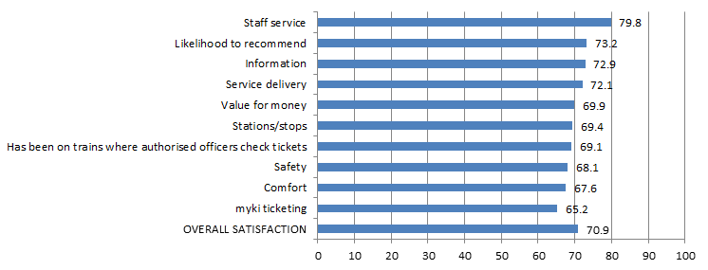

Table 14a: Satisfaction with key service aspects for metropolitan trains
Satisfaction indicator | Score | Significant change from previous quarter
Staff service | 79.8 | decrease
Likelihood to recommend | 73.2 | decrease
Information | 72.9
Service delivery | 72.1
Safety | 68.1 | decrease
Value for money | 69.9
Has been on trains where authorised officers check tickets | 69.1
Stations/stops | 69.4
Comfort | 67.6 | decrease
myki ticketing | 65.2 | decrease
OVERALL SATISFACTION | 70.9 | decrease

Metropolitan trams
Figure 5b: Satisfaction with key service aspects for metropolitan trams
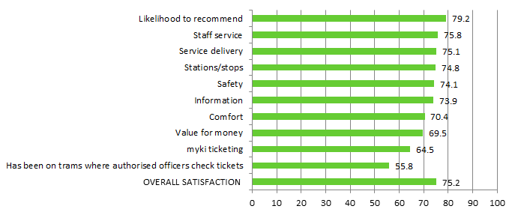

Table 14b: Satisfaction with key service aspects for metropolitan trams
Satisfaction indicator | Score | Significant change from previous quarter
Likelihood to recommend | 79.2 | decrease
Staff service | 75.8
Stations/stops | 74.8
Safety | 74.1 | decrease
Service delivery | 75.1
Information | 73.9
Comfort | 70.4
Value for money | 70.6
myki ticketing | 64.5
Has been on trams where authorised officers check tickets | 55.8
OVERALL SATISFACTION | 75.2

Metropolitan buses
Figure 5c: Satisfaction with key service aspects for metropolitan buses
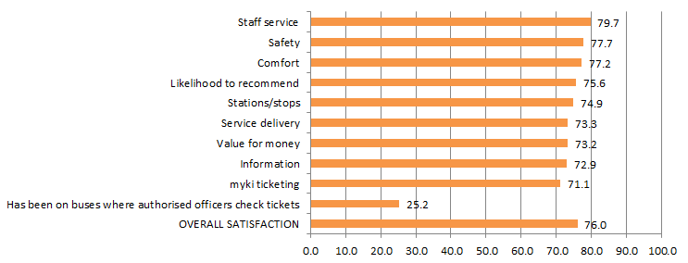

Table 14c: Satisfaction with key service aspects for metropolitan buses
Satisfaction indicator | Score | Significant change from previous quarter
Staff service | 79.7
Safety | 77.7
Comfort | 77.2
Likelihood to recommend | 75.6
Service delivery | 73.3 | decrease
Stations/stops | 74.9
Information | 72.9
Value for money | 73.2
myki ticketing | 71.1
Has been on buses where authorised officers check tickets | 25.2
OVERALL SATISFACTION | 76.0

V/Line modes
Table 15a: V/Line trains individual overall satisfaction
Mode | Apr – Jun 2014 | Jul – Sep 2014 | Oct – Dec 2014 | Jan – Mar 2015 | Apr – Jun 2015 | Jul – Sep 2015 | Oct – Dec 2015 | Jan – Mar 2016 | Apr – Jun 2016
V/Line trains | 75.8 | 77.3 | 75.4 | 75.7 | 76.9 | 76.2 | 78.8 | 73.8 | 74.5

Table 15b: V/Line coaches individual overall satisfaction
Mode | Apr – Jun 2014 | Jul – Sep 2014 | Oct – Dec 2014 | Jan – Mar 2015 | Apr – Jun 2015 | Jul – Sep 2015 | Oct – Dec 2015 | Jan – Mar 2016 | Apr – Jun 2016
V/Line coaches | 81.4 | 80.3 | 80.8 | 84.6 | 85.7 | 83.9 | 86.1 | 81.6 | 78.4

Figure 6: V/Line individual overall satisfaction – trains and coaches

V/Line trains
Figure 7a: Satisfaction with key service aspects for V/Line trains
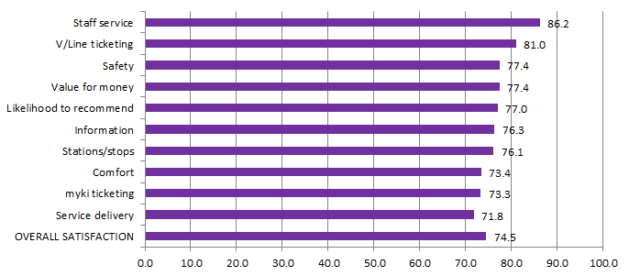
Table 16a: Satisfaction with key service aspects for V/Line trains
Satisfaction indicator | Score | Significant change from previous quarter
Staff service | 86.2
V/Line ticketing | 81.0
Safety | 77.4
Stations/stops | 76.1 | decrease
Value for money | 77.4
Likelihood to recommend | 77.0
Information | 76.3
Comfort | 73.4
Service delivery | 71.8
myki ticketing | 73.3
OVERALL SATISFACTION | 74.5

V/Line coaches
Figure 7b: Satisfaction with key service aspects for V/Line coaches
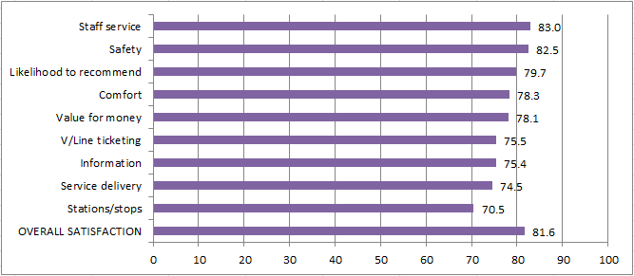

Table 16b: Satisfaction with key service aspects for V/Line coaches
Satisfaction indicator | Score | Significant change from previous quarter
Value for Money | 78.1 | decrease
Staff service | 83.0
Safety | 82.5
Likelihood to recommend | 79.7
Information | 75.4 | decrease
Comfort | 78.3
V/Line ticketing | 75.5
Service delivery | 74.5
Stations/stops | 70.5 | decrease
OVERALL SATISFACTION | 78.4 | decrease

Travel behaviour and ticketing

Travel behaviour
The proportion of non-users of public transport continues to remain stable in the June 2016 quarter with 7 per cent stating they hardly ever or never use public transport.
Figure 8: Main purpose of trip on weekday and weekend

Table 17: Main purpose of trip on weekday and weekend
 | Weekday (Apr – Jun 2016) | Weekend (Apr – Jun 2016)
To get to / from work | 36% | 7%
To get to / from leisure activities | 45% | 82%
To get to / from place of study | 10% | 2%
To get errands / chores/ day to day tasks done | 29% | 20%
Something else | 0% | 0%
The most popular reason for using public transport on weekdays is for leisure purposes (45 per cent), which continues to lead commuting to work (36 per cent).
Weekend travel continues to be dominated by leisure purposes (82 per cent).

myki device availability
A private company, NTT Data Victorian Public Ticketing System Pty Ltd, is under contract to the Victorian Government to operate and maintain the myki ticketing system for Victoria’s public transport network.

Measurements included in the contract include targets to represent minimum levels of acceptable availability and performance, and specified levels of non-availability due to maintenance, servicing and breakdowns.

Table 18: Month-by-month NTT Data Key Performance Indicator calculated availability (per cent)

Equipment | Apr 2016 | May 2016 | June 2016
myki gate | 99.9448% | 99.9520% | 99.9687%
myki reader (mobile) | 99.9989% | 99.9993% | 99.9994%
myki reader (stationary) | 99.9998% | 99.9999% | 99.9999%

Figure 9: Month-by-month NTT Data Performance Indicator calculated availability (per cent)

Monitoring of ticketing equipment

The status of ticketing equipment at railway stations is monitored via fixed communication. NTT Data therefore, has accurate and up-to-date information on the availability of ticketing machines at railway stations and can promptly schedule repairs or servicing.

Mobile equipment on board trams and buses utilises wireless communications. Tram and bus operators are required to make vehicles with faulty equipment available to NTT Data for repairs and services. Measures and performance targets vary between modes.

Fare evasion
Attitudes toward Authorised Officers
Figure 10: Attitudes toward Authorised Officers (per cent)

Table 19: Detailed attitudes toward Authorised Officers
Attitudes towards authorised officers | Apr – Jun 2015 | Jul – Sep 2015 | Oct – Dec 2015 | Jan – Mar 2016 | Apr – Jun 2016
Neutral | 56% | 49% | 30% | 44% | 43%
Pleased | 15% | 16% | 27% | 18% | 18%
More secure | 18% | 19% | 22% | 18% | 23%
Annoyed | 2% | 4% | 6% | 5% | 5%
Nervous | 5% | 3% | 5% | 4% | 3%
Harassed | 1% | 3% | 3% | 4% | 2%
Have not seen them | 2% | 4% | 8% | 8% | 6%
Sample size | 400 | 503 | 400 | 400 | 400
Over a third (41 per cent) of public transport users reported feeling positive towards Authorised Officers in the June 2016 quarter, up from last quarter (36 per cent).

The increase in overall positive feelings is driven due to an increase in those feeling ‘neutral’ (from 30 per cent last quarter to 44 per cent this quarter).

Customer service

Website
PTV’s website provides journey planning, timetable, ticketing and marketing information for metropolitan Melbourne and regional Victoria. The PTV mobile phone apps for iPhones and Android handsets feature timetable and journey planning information.
Table 20: Website performance
 | Apr 2016 | May 2016 | Jun 2016 | Quarter total | Quarter on quarter change* | Year on year change*
Visits | 4.1m | 3.8m | 3.9m | 11.8m | -12% | 5%
Visitors | 1.8m | 1.7m | 1.8m | 4.4m* | -10% | 7%
Pageviews | 11.2m | 10.3m | 10.5m | 32.0m | -15% | 2%
*The quarter total for unique visitors may be higher than the aggregate of the three months as a visitor may visit the website more than once during a month, but is only counted once in the quarter total.
The PTV website received 11.8 million visits from customers in the June quarter. This is down 12% on the seasonal spike of the previous quarter’s record total, but still up 5% year-on-year.

Journey planner

Customers planned a record 35.4 million journeys using PTV’s journey planner across our website, mobile phone apps and call centre during the quarter. This is a 10% decrease on the record total of the previous quarter, but still up 25% on the same period last year.

News and service alterations

Level crossing improvements works were among the most popular news topics during the quarter, with an article about station closures and alterations on the Frankston line being viewed 223,000 times.

An article about ongoing V/Line cancellations and coach replacements also proved popular, being viewed 139,000 times.

Mobile apps

Customers used PTV’s mobile apps in 14.2 million sessions, with apps being installed on 147,000 new devices during the quarter.

Figure 11: Website visits

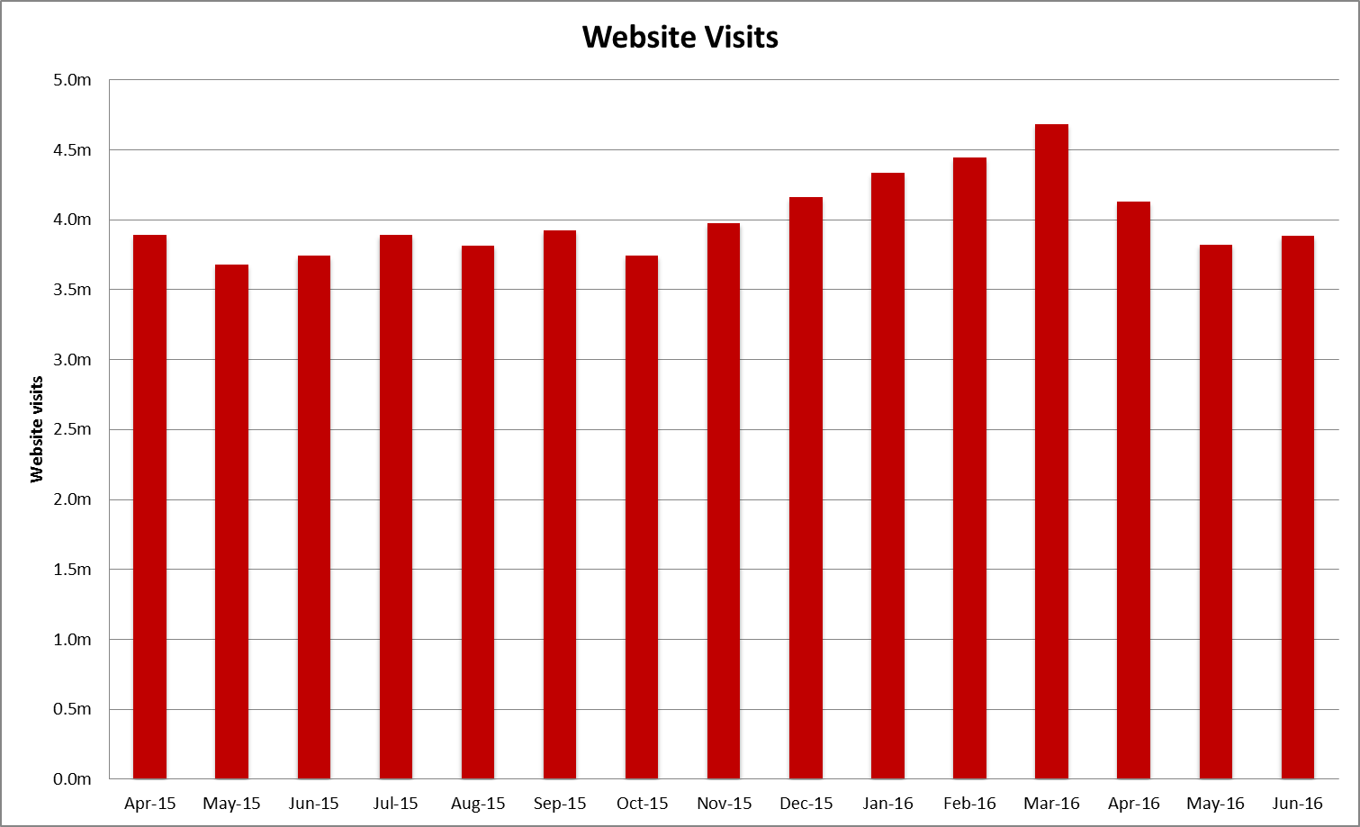
Source: Google analytics
Table 21: Website visits
Month | Apr 2015 | May 2015 | Jun 2015 | Jul 2015 | Aug 2015 | Sep 2015 | Oct 2015 | Nov 2015 | Dec 2015
Pageviews | 10,656,664 | 9,931,612 | 10,733,268 | 10,891,310 | 10,398,847 | 10,723,050 | 10,053,883 | 11,047,132 | 11,422,931
Visitors | 1,695,067 | 1,609,900 | 1,667,018 | 1,686,169 | 1,628,928 | 1,720,521 | 1,655,989 | 1,755,162 | 1,845,806
Visits | 3,891,184 | 3,681,972 | 3,743,489 | 3,895,115 | 3,819,592 | 3,928,755 | 3,746,178 | 3,978,079 | 4,162,017

Month | Jan 2016 | Feb 2016 | Mar 2016 | Apr 2016 | May 2016 | June 2016
Pageviews | 12,520,822 | 12,570,239 | 12,715,156 | 11,168,584 | 10,298,449 | 10,518,701
Visitors | 1,964,263 | 1,938,322 | 1,997,612 | 1,805,532 | 1,688,493 | 1,779,346
Visits | 4,334,701 | 4,446,234 | 4,686,265 | 4,131,197 | 3,824,990 | 3,887,248

Call Centre
PTV’s Call Centre provides journey and ticket information for metropolitan and regional services, as well as taking reservations and payment for V/Line tickets. It also collects feedback on behalf of all operators.
Table 22: Call Centre calls received
Measure | Apr-16 | May-16 | Jun 2016 | Quarter Total | Quarter on quarter change | Year on year change
Calls received | 104,273 | 97,020 | 99,067 | 300,360 | -28.2% | -2.3%
Call volumes decreased 28.2 per cent this quarter and decreased 2.3 per cent against the same period last year.
Figure 12: Call Volumes and Grade of Service (per cent)
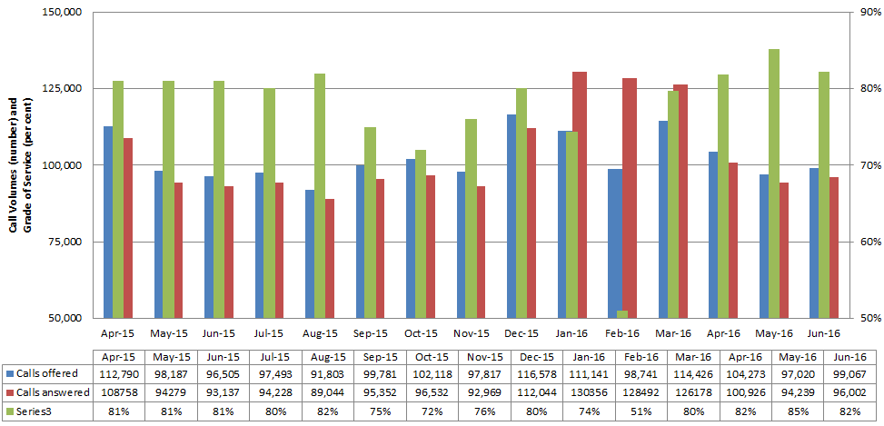
Table 23: Call Volumes and Grade of Service (per cent)
Calls | Apr 2015 | May 2015 | Jun 2015 | Jul 2015 | Aug 2015 | Sep 2015 | Oct 2015 | Nov 2015 | Dec 2015 | Jan 2016 | Feb 2016 | Mar 2016 | Apr 2016 | May 2016 | Jun 2016
offered | 112,790 | 98,187 | 96,505 | 97,493 | 91,803 | 99,781 | 102,118 | 97,817 | 116,578 | 111,141 | 98,741 | 114,426 | 104,273 | 97,020 | 99,067
answered | 108,758 | 94,279 | 93,137 | 94,228 | 89,044 | 95,352 | 96,532 | 92,969 | 112,044 | 130,356 | 128,492 | 126,178 | 100,926 | 94,239 | 96,002
GOS% | 81% | 81% | 81% | 80% | 82% | 75% | 72% | 76% | 80% | 74% | 51% | 80% | 82% | 85% | 82%
The Grade of Service target of 80 per cent of calls answered within 30 seconds was met in April (82 per cent), May (85 per cent) and June (82 per cent).

Industry-wide feedback

About industry feedback
Feedback data from all operators who have Resolve (Metro, Yarra, V/Line and PTV), is collected in a central database to aid industry-wide reporting and analysis. Bus data is provided to PTV by BusVic on behalf of its members.

Stakeholder share
During the June quarter, stakeholders reported receiving 21,412 cases (excluding special needs booking requests); this was a 16 per cent decrease on the previous quarter, and down by 13 per cent year-on-year.
PTV received 3,806 primary cases during the quarter; a 17 per cent decrease on the previous quarter, and a decrease of 27 per cent year-on-year.
Figure 13: Resolve – Stakeholder share

Table 24: Resolve – Stakeholder share
Operator | Total number of cases | Share of all cases | Quarter-on-quarter change | Year-on-year change
Metro | 5,712 | 27% | -19% | -13%
Yarra Trams | 3,265 | 15% | -10% | -49%
Bus | 5,632 | 26% | -4% | 53%
V/Line | 2,997 | 14% | -30% | 5%
PTV | 3,806 | 18% | -17% | -27%
Total | 21,412 | 100% | -16% | -13%
* Special needs booking requests have been removed
Types of feedback
Figure 14: Types of feedback

Table 25: Types of feedback
Feedback type | Percentage
Complaint | 77.2%
Compliment | 3.5%
Enquiry | 7.0%
Others | 2.5%
Suggestion | 9.8%

Industry feedback
Figure 15: Top five feedback issues across the industry

Note: Top issues for cases entered into the Resolve database (excluding performance-based compensation claims and compliments).
Table 26: Top five feedback issues across the industry
Issue | Percentage
Service delivery | 27.1%
Provision of information | 18.7%
Infrastructure | 16.4%
Staff | 16.1%
Ticketing and policy | 8.0%
Note: Top issues for cases entered into the Resolve database (excluding performance-based compensation claims and compliments).
Table 27: Breakdown of top industry issue*
Issue | Percentage
Service Disruption | 20.1%
Delayed | 16.3%
Cancellation | 8.8%
Service Change Needed | 7.6%
Bus replacements | 7.0%
*Top issue: Service Disruption: 20.1 per cent of cases
Note: Bus industry feedback categorisation does not currently allow for analysis beyond the top PTV issues feedback.

PTV feedback
Excluding compliments, provision of information was the top feedback issue of the quarter, accounting for almost 30 per cent of PTV cases.

Mobile Products accounted for nearly 39 per cent of the feedback received under provision of information. 30 per cent of the feedback came from the iPhone - PTV App 3.1.0.
Other issues consist of:
- Technical issues
- Future Enhancement
- Ease of use
Ticketing and policy accounted for 21 per cent of all PTV Cases. Requests include:
- Service Change Needed
- System Improvement
- Compensation Request
Some 1.5 per cent of cases received during the quarter were compliments. The top compliments were staff and provision of information (accounting for 68 per cent of compliments)
- 74 per cent of the compliments from Staff related to Call Centre
- 40 per cent of the compliments from Provision of information related to Mobile Products

Figure 16: PTV top five feedback issues

Note: Bus industry feedback categorisation does not currently allow for analysis beyond the top PTV issues feedback.
Table 28: PTV top five feedback issues
Issue | Percentage
Provision of Information | 29.8%
Service delivery | 21.1%
Ticketing and policy | 19.7%
Infrastructure | 17.1%
Staff | 9.6%
Note: Top issues for cases entered into the Resolve database (excluding performance-based compensation claims and compliments).
Table 29: Breakdown of top PTV issue*
Issue | Percentage
Mobile Products | 38.7%
Timetable | 18.5%
Website | 15.0%
Journey Planner | 9.3%
Information Request | 7.8%
*Top PTV issue: Provision of Information: 29.8 per cent of cases
Note: Bus industry feedback categorisation does not currently allow for analysis beyond the top PTV issues feedback.

