Network Revenue Protection Plan – 2022

Department of Transport
Metro Trains Melbourne
Yarra Trams
Bus Association Victoria
V/Line
Ventura
Metropolitan Bus Franchise

Table of Contents

1. INTRODUCTION AND PURPOSE 3
1.1. Overview 3
1.2. Revenue protection themes 3
1.3. Revenue protection priorities 4
1.4. Link between NRPP and operator revenue protection plans 4
1.5. Structure of the plan 4
2. BACKGROUND AND CONTEXT 5
2.1. Definition of fare evasion 5
2.2. Recent fare compliance levels 5
2.3. Revenue impact of fare evasion 6
2.4. A collaborative approach 6
2.5. A fair approach to fare compliance 7
2.6. Additional Authorised Officers 7
2.7. Overview of 2021 NRPP activities 8
3. FARE COMPLIANCE STRATEGY 9
3.1. Revenue protection themes 9
3.2. Responsibility for maximising fare compliance 10
4. 2022 REVENUE PROTECTION PRIORITIES 11
4.1. Coronavirus recovery (continuing from 2021) 11
4.1.1. Context 11
4.1.2. Actions 12
4.2. Supporting the transition to cashless ‘pre-pay’ buses (continuing from 2021) 12
4.2.1. Context 12
4.2.2. Actions 13
5. Other Actions Aligned with The Four Themes Of Revenue Protection 13
5.1. Making the ticketing system easier to use 13
5.2. Compliance support 14
5.3. Ticket checking and Reports of Non-Compliance 14
5.4. Marketing and education campaigns 14
6. MEASUREMENT AND MONITORING 14
6.1. Revenue protection key performance indicators 14

INTRODUCTION AND PURPOSE

Overview
Under the relevant contractual arrangements, The Department of Transport (DoT) and public transport operators are required to produce an annual Network Revenue Protection Plan (NRPP) that describes how DoT, public transport operators, and Bus Association Victoria (BusVic) work together to protect revenue and implement Government policy across the public transport network.
Throughout much of 2020 and 2021 the coronavirus (COVID-19) pandemic caused a substantial amount of disruption to public transport use and the revenue protection activities laid out in previous NRPPs.
Despite the challenges, several initiatives have been introduced in 2021 aimed at making the ticketing system easier to use. DoT introduced myki Money instant top up in August that allows passengers using the PTV app on their smartphone to always be travel ready. DoT also rolled out more than 1,600 faster myki readers, installed new Quick Top Up Enquiry Machines (QTEM) and delivered limited marketing campaigns where appropriate to promote fare compliance and contactless ways of topping up.
To track and measure fare compliance DoT normally conducts twice-yearly Fare Compliance Surveys each May and October. In October 2019 a record 96.8 per cent of passengers on the metropolitan network were fare compliant. Due to the impacts of COVID-19 on public transport usage and social distance requirements, DoT could not conduct surveys in 2020 and only one survey could be conducted in May 2021.
The results from May 2021 found that 93.8 per cent of passengers on the metropolitan network were fare compliant, a fall of 3 per cent from the record high result measured prior to COVID-19. The full impacts COVID-19 may have on fare compliance will become clearer in 2022 once more passengers return to the network and subsequent Fare Compliance Surveys are conducted.
While the full extent of COVID-19 impacts on fare compliance are still unfolding, the May 2021 results show that even during a pandemic the vast majority of passengers in Victoria choose to do the right thing.
More passengers are expected to return to the public transport network in 2022 as coronavirus restrictions ease with increased vaccination rates and other measures. When this happens, it is important that revenue protection activities continue to be undertaken in a way that targets deliberate fare evasion, while reducing the chance of inadvertent fare evasion by making it easier for everyone to travel with a valid ticket.
This plan continues the collaborative approach between DoT, operators and BusVic. It builds on previous work that focuses on maximising the number of passengers who travel with a valid ticket while also providing a high-quality passenger experience.

Revenue protection themes
The complexity of fare evasion behaviour means that a range of activities are required for effective revenue protection. As in previous years, the 2022 plan is based on four revenue protection themes:
- making the ticketing system easier to use: continuous improvement to the ticketing system to make it easier to use, access and understand, with the aim of improving the passenger experience
- compliance support: compliance promotion measures such as staff at stations and on trains, trams and buses and ticket barriers at railway stations
- ticket checking: Authorised Officers (AOs) checking tickets and reporting non-compliance to DoT
- marketing and education: customer information campaigns to help passengers be ready to travel and use high readiness products, as well as making it easier to use myki by continually improving education on how to use the ticketing system.
More detail on the four revenue protection themes can be found in section 3.1 below.

Revenue protection priorities
Supplementing the four themes, the two revenue protection priority areas for 2022 are:
- Coronavirus recovery (continuing from 2021)
- Supporting the transition to cashless ‘pre-pay’ buses (continuing from 2021)
These priority areas, detailed in section 4, build on priorities from previous plans, such as:
- undertaking revenue protection activities in a way that improves passenger experience
- increasing passengers’ awareness and frequency of myki touch ons.

Link between NRPP and operator revenue protection plans
The 2022 NRPP focuses on network-wide priorities supported by activities on each mode. In addition, Metro Trains, Yarra Trams, V/Line and the Metropolitan Bus Franchisee prepare individual plans that include revenue protection priorities.
Revenue protection activities differ between operators and modes, but they all align with the overall objective of achieving a high level of fare compliance in a fair and equitable way.

Structure of the plan
The plan covers:
- background and context of Victoria’s revenue protection approach
- an overview of the fare compliance strategy
- revenue protection priorities for 2022
- revenue protection actions agreed by DoT and transport operators
- arrangements to implement and monitor revenue protection actions.
The plan will be implemented by the Revenue Protection Plan Implementation Committee (RPPIC), which includes representatives from DoT, operators and BusVic.
- BACKGROUND AND CONTEXT

Definition of fare evasion
The vast majority of public transport passengers in Victoria are fare compliant and travel with valid tickets. People travelling without a valid ticket are fare evading and this can be either inadvertent or deliberate. The Victorian Fares and Ticketing Conditions defines the conditions for valid tickets and can be accessed on the PTV website.

Recent fare compliance levels
Fare compliance is measured through surveys conducted twice a year in May and October. The estimated rate of fare compliance since 2011 is shown in figure 1 below.
Over this period, fare compliance on the metropolitan public transport network was lowest in May 2013 at 88.1 per cent. In October 2019, the metropolitan network result was highest at 96.8 per cent.
Due to the impacts of COVID-19 on public transport usage and social distancing requirements, the Fare Compliance surveys could not safely go ahead in 2020 or October 2021.
The May 2021 Fare Compliance survey has been the first formal measure of fare compliance since the COVID-19 pandemic began and shows a reduction in fare compliance across all modes.
For May 2021, the metropolitan network fare compliance was 93.8 per cent, metropolitan tram remains the highest mode at 96.2 per cent and metropolitan bus recorded the lowest at 90.6 per cent.

Figure 1: Fare compliance by mode – May 2011 to May 2021
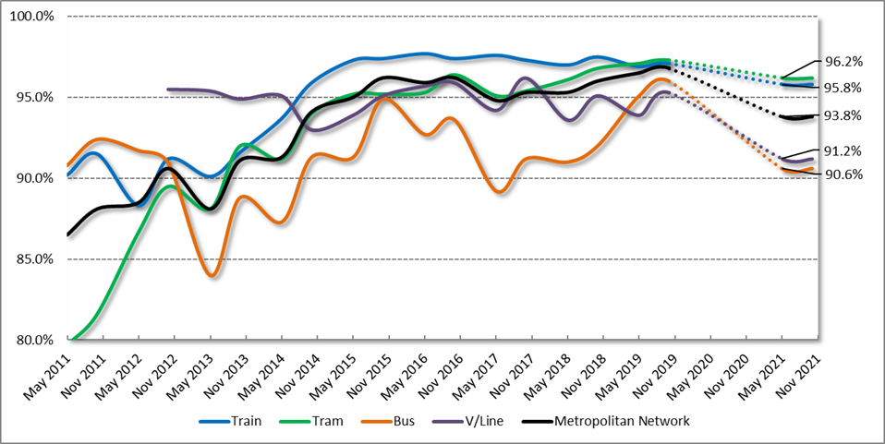
*NOTE: dotted lines indicate period in 2020 with no fare compliance surveys.
While it is not possible to know exactly why fare compliance was lower in May 2021, possible factors are;
- a change in the mix of passengers using the network in 2021 due to COVID-19
- the permanent removal of cash from the myki bus networks in 2020.
A clearer indication of how the above factors may have impacted fare compliance is anticipated once more passengers return to public transport and subsequent surveys can be conducted in 2022.

Revenue impact of fare evasion
The loss of farebox revenue during the first six months of 2021 was estimated at $12.2 million ($9.9 million for the metropolitan network and $2.3 million for regional trains). Estimated revenue for this period was approximately $201 million (approximately $175 million for the metropolitan network and $26 million for regional trains).
For the equivalent six months in 2019, estimated loss of farebox revenue was $16.7 million (13.2 million for the metropolitan network and $3.5 million for regional trains). At first glance the difference appears to be small, however, estimated total revenue at that time was 56% higher for the metropolitan network (approximately $399 million) and 51% higher for regional trains (approximately $53 million).

A collaborative approach
DoT, public transport operators and BusVic have developed a collaborative approach to managing the shared challenges of fare compliance across the public transport network.
This has promoted innovation and flexibility, which has contributed to strong fare compliance and a more consistent experience for passengers.
Metro Trains and Yarra Trams hold revenue risk via a sharing arrangement for total metropolitan farebox revenue. Accordingly, these operators have a financial incentive to attract more passengers and increase fare compliance on all modes across the network, not just their own services.

A fair approach to fare compliance
The Government commenced implementing the Ticketing Compliance and Enforcement reforms (TCE) in 2016 following the release of the DoT (formerly DEDJTR) Ticketing Compliance and Enforcement Review and the Victorian Ombudsman’s Investigation into public transport fare evasion enforcement.
The TCE reforms aimed to strike a better balance between efficiency and fairness in ticketing compliance and enforcement by focusing enforcement activity towards deliberate and recidivist fare evasion and more systematic discretion and use of official warnings in cases of inadvertent non-compliance.
To support these reforms, since 2016 all AOs have received additional training in conflict management and awareness of special circumstances.
The success of these reforms is evident in:
- an increase in customer satisfaction with AOs
- a reduction in the number of AO related investigations opened by the Public Transport Ombudsman (PTO)
- continued high rates of fare compliance
- fewer injuries sustained by AOs
- a substantial reduction in the number of court cases involving public transport infringements and cessation of prosecuting cases where there is evidence of special circumstances.
This plan also acknowledges that operators have continued working on improving passenger experience through initiatives including updated staff training, greater emphasis on customer service/education focussed activities and the recruitment of AOs from a broad range of backgrounds and experience.
Improving passenger experience is embedded in the current metropolitan train and tram contracts which is continuing to show positive results and will be further developed during 2022.

Additional Authorised Officers
The 2019/20 State Budget included funding for ten additional AOs to be recruited each year for 10 years, resulting in a total of 100 new AOs on the network. These additional AOs will provide an important increase in capacity to support revenue protection, safety and customer service across the network.
When determining the most appropriate distribution for each trance of additional AOs, consideration is given to a range of factors including;
- patronage
- Fare Compliance survey results
- existing staff on the network
- special events, planned and unplanned disruptions requiring AO support.

For financial year 2022/23 the 10 additional AOs will be employed as:
- 2 Metro Trains Melbourne
- 3 Yarra Trams
- 2 V/Line
- 3 MMAO (focusing primarily on metropolitan and regional bus).

Overview of 2021 NRPP activities
The continued impacts of COVID-19 throughout 2021 including periods of lockdown in Victoria have caused significant disruption to patronage as well as changing how passengers interact with the ticketing system. Suspension of cash handling is one example of this.
Similar to 2020, the challenges presented by COVID-19 has meant fully implementing and measuring the 2021 NRPP actions has not been possible.
The below list outlines activities undertaken throughout 2021 to date aligned with the four revenue protection themes.
- Making the ticketing system easier to use:
- introduction of a myki instant top up feature, meaning passengers can top up their myki Money balance using the PTV app on their mobile phone anytime, anywhere
- continued development of new PTV website and next gen PTV mobile app to further enhance myki ticketing integration
- more than 1,600 faster myki readers and 10 QTEMs installed across the network (year to date as at 1 November 2021).
- Compliance Support:
- introduction of new technology to further improve consistency of keeping ticket barriers closed and staffed
- bus operators have continued to improve their performance in ensuring ticketing devices are operational.
- Ticket checking:
- DoT and operators maintaining COVID-Safe ticket checking and enforcement practices
- maintaining high visibility of AOs across the network through smaller average team sizes and COVID-Safe ways of working.
- Marketing and education:
- marketing activities during 2020 were adapted to promote COVIDSafe ways of travel, including cashless ways to top up a myki and promotion of travel readiness
- limited marketing campaigns in support of alternate ‘cashless’ top up options
- myki registration incentive program for 60,000 new registrations
- operator’s face-to-face community education activities such as school presentations by AOs have largely remained suspended in 2021 due to COVID-19. Some presentations have been moved online
- continuation of non-enforcement customer education activities by AOs to positively influence fare compliance in a COVID Safe way.
- FARE COMPLIANCE STRATEGY

Revenue protection themes
The complexity of fare evasion behaviour means that a range of actions are required for effective revenue protection. Accordingly, the approach used by DoT and public transport operators is based on the four themes outlined in section 1.2.
Figure 2: Four themes of revenue protection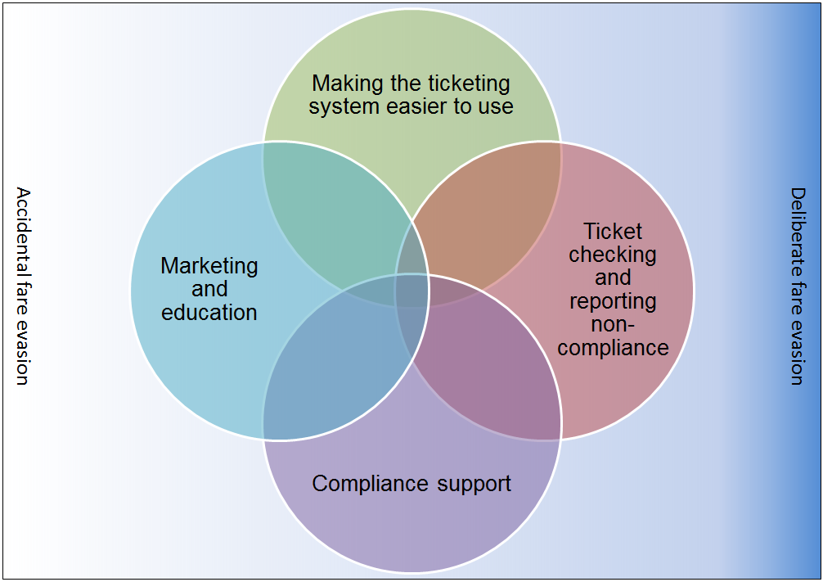
Each of the above themes in Figure 2 is important but none is sufficient on its own. Together, they support a suite of revenue protection measures that aim to make it easy for passengers to do the right thing and harder to deliberately and repeatedly fare evade.
Moreover, the culture of fare compliance extends to public transport staff each understanding the important role they play in supporting revenue protection. This includes frontline transport staff such as V/Line Conductors and railway station staff, tram Customer Service Employees and bus drivers.
The aim is to encourage passengers to see travelling with valid tickets as the norm while, at the same time providing better information to improve the passenger experience and reduce the likelihood of inadvertent fare evasion.
Using a revenue protection approach aligned to these four themes, fare compliance reached high levels across all modes prior to COVID-19 along with improved customer satisfaction and low complaints. Continuing this approach is the aim of the 2022 revenue protection actions as Victorians continue to adapt and recover from the substantial disruption caused by COVID-19.

Responsibility for maximising fare compliance
Operators are required to meet a number of contractual obligations under their Agreements with DoT. While the conditions vary between operators, some key elements are:
- using reasonable endeavours to ensure passengers have valid tickets (including eligibility for concessions)
- employing and deploying agreed numbers of AOs
- working with DoT to develop, implement and comply with a Network Revenue Protection Plan
- maintaining accurate records and providing reports to DoT on revenue protection measures
- managing customer service staff to maximise fare compliance, (e.g. through closing/staffing ticket barriers at stations, providing information at tram and bus stops)
- supporting the conduct of the fare compliance survey through commitment of AOs and in the case of V/Line, train Conductors
- providing timely and accurate metrics to support monitoring of revenue protection activities.
DoT is responsible for:
- strategic public transport policy in relation to fares, ticketing, compliance and enforcement
- setting the strategic framework for revenue protection
- regulatory and legislative change relating to enforcement
- issuing and processing ticket infringement notices
- promoting innovation and overseeing specific initiatives to lead the industry
- managing updates to the ticketing conditions and new policy
- developing and undertaking marketing and information campaigns
- overseeing the operation and continued development of the myki system
- monitoring operator performance in line with contractual arrangements
- accrediting and regulating AOs to ensure they have the authorisation required to undertake their duties.
- undertaking regular fare compliance surveys, sharing the results with operators and publishing overall results in a timely fashion
- developing overall strategy and deployment plans for Multi-Modal Authorised Officers (MMAO) and ensuring implementation of the plan.
The Revenue Protection Plan Implementation Committee is responsible for delivery of the initiatives contained in this plan. Members of this group represent:
- Department of Transport
- Metro Trains Melbourne
- Yarra Trams
- Bus Association Victoria
- Ventura
- Metropolitan Bus Franchise
- V/Line.
This group will continue to meet every second month, with revenue protection meetings being held with individual modes in the intervening months.
- 2022 REVENUE PROTECTION PRIORITIES
As noted in Section 1, two priority areas underpin the initiatives to improve fare compliance levels in 2022. These are discussed in more detail below.

Coronavirus recovery (continuing from 2021)

Context
The TCE reforms outlined in section 2.5 and consistently maintaining the four themes of revenue protection detailed in sections 1.2 and 3.1 have resulted in significant improvements in customer experience with AOs on the public transport network and record high levels of fare compliance in 2019.
Due to the ongoing challenges presented by COVID-19 throughout much of 2020 and the year to date, substantial changes to patronage and the way revenue protection activities can be undertaken are continuing. This, coupled with the inability to safely conduct fare compliance surveys during 2020 or October 2021, has meant that it is too early to understand the full impacts COVID-19 may have on fare compliance.
Because past Fare Compliance Survey results and research shows that the vast majority of Victorians to do the right thing and travel with a valid ticket, the key activities for 2022 will be to maintain COVID Safe versions of the revenue protection activities that worked well prior to COVID-19 and support passengers to make a fare compliant return to the network.
Marketing and passenger information will continue to be critical as patronage returns and Victoria moves towards ‘COVID normal’. Activities will be focused on achieving the right behaviour and ensuring passengers are ‘travel ready’ by having a valid myki prior to travel. This will include a combination of marketing, digital messages and signage.

Actions
- Support passengers returning to public transport after long absences to be ticket ready - DoT, metropolitan train, tram, bus, V/Line.
- Ensure COVID Safe practices are in place for all aspects of revenue protection - DoT, metropolitan train, tram, bus, V/Line.
- Continue to improve support for vulnerable passengers’ accessing public transport – DoT.

Supporting the transition to cashless ‘pre-pay’ buses (continuing from 2021)

Context
Prior to 2020 several of Victoria’s busiest bus routes such as route 601 were pre-pay and it was planned that cash payments on myki buses would be gradually phased out over two years to bring ticketing on myki buses in line with trams.
Benefits of pre-pay buses include faster journeys, improved reliability and opportunities for further bus network improvements like rapid running (running high frequency route buses in real time to no scheduled timetable). Pre-pay is an important feature of Victoria’s Bus Plan released in June 2021.
In response to COVID-19, cash handling was ceased across the network by the end of March 2020. This change was made permanent on myki buses in July 2020, meaning passengers were required to purchase or top up their myki prior to boarding the bus.
The sudden removal of the cash payment option from myki buses has been recognised as an important revenue protection challenge into 2022. It is acknowledged that some passengers who previously topped up on buses using cash will need time and help to adjust and that convenient alternative options are made available.
Work to improve awareness and provide convenient alternative top-up options commenced in 2020 and has continued throughout 2021. For example:
- key bus locations identified for new retailer or QTEM installation
- implemented myki Money instant top up feature, so passengers can top up their myki Money card balance using the PTV app on their mobile phone anytime, anywhere
- implemented and monitored an enforcement transition approach to ensure fairness for passengers who intend to travel with a valid ticket
- ongoing improvements to myki top-up feature of PTV’s website and app
- marketing campaigns promoting cashless alternatives in early 2021.
Because COVID-19 has continued to keep passengers away from the network and restrict movement, various activities such as additional marketing activities and training new retailers will need to be continued into 2022. These activities are intended to support transitioning passengers to suitable alternatives that are, ideally, low effort and contactless.
Figure 3: supporting the transition to pre-pay for bus passengers

In addition to the new and existing methods for topping up and purchasing a myki, other options are being explored to improve top-up availability for all public transport users.

Actions
- Optimise myki ticketing and retail networks to provide convenient top up options at key bus interchanges – DoT.
- Develop and deliver marketing and on-system messaging to promote alternatives to bus top ups including cashless options – DoT.
- Other Actions Aligned with The Four Themes Of Revenue Protection
In addition to the activities associated with the two priority areas, the following actions will be delivered by DoT, BusVic and public transport operators during 2022. Actions have been categorised according to the strategic elements identified in Section 3.

Making the ticketing system easier to use
- Oversee the operation and continued development of the myki system – DoT.
- Continue to make the myki system easier to use through progressive improvements – DoT.

Compliance support
- Communicate regularly with staff to remind them of the importance of fare compliance – DoT, metropolitan train, tram, bus, V/Line.
- Continue to promote driver compliance with correct bus driver console usage and fault reporting – bus.
- Continue strategies to support revenue protection activities by V/Line Conductors and other staff – DoT, V/Line.
- Continue to staff and close wide ticket barriers at gated stations in line with contractual arrangements – metropolitan trains, V/Line.

Ticket checking and Reports of Non-Compliance
- Deploy AOs strategically, using survey and other data, to a combination of high value areas and general network coverage to normalise fare compliance – DoT, metropolitan train, tram, bus, V/Line.
- Continue to increase the visibility of AOs across the public transport network - DoT, metropolitan train, tram, bus, V/Line.
- Continue to improve consistency of AO’s use of discretion for cases of special and exceptional circumstances – DoT, metropolitan train, tram, bus, V/Line.

Marketing and education campaigns
- Develop and deliver messaging to encourage passengers to travel with a valid ticket at all times and build better understand of the ticketing system – DoT.
- Give presentations at schools and universities to educate students on behavioural requirements and the need to have a valid ticket – metropolitan train, tram, bus, V/Line.
- Improve promotion of high readiness ticketing products by AOs, V/Line train Conductors and frontline staff – DoT, metropolitan train, tram, bus, V/Line.
- MEASUREMENT AND MONITORING

Revenue protection key performance indicators
DoT and operators work together to establish a consistent set of metrics that can be monitored to assess the effectiveness of revenue protection activities. These indicators are aligned with the TCE reforms and reflect the breadth of revenue protection activities, including:
- Fare Compliance Survey results
- Touch on rate survey
- Customer satisfaction with AOs
- Customer satisfaction with the myki ticketing system
- Proportion of passengers using ‘high readiness’ ticketing products
Revenue protection metrics are regularly reviewed to ensure they remain relevant and changes are made where improvements are identified, or different metrics are required.
Operators also use a range of metrics for planning and monitoring their own revenue protection activities. They work with DoT to coordinate activities and monitor revenue protection trends across the network
As in previous years, DoT and operators will share relevant data and prepare specific reports to inform the development and implementation of revenue protection activities.

