Network Revenue Protection Plan – 2020

Department of Transport
Metro Trains Melbourne
Yarra Trams
Bus Association Victoria
V/Line
Ventura
Transdev

Table of Contents
1 INTRODUCTION AND PURPOSE 3
1.1 Overview 3
1.2 Revenue protection themes 3
1.3 Revenue protection priorities 3
1.4 Link between NRPP and operator revenue protection plans 4
1.5 Structure of the plan 4
2 BACKGROUND AND CONTEXT 4
2.1 Definition of fare evasion 4
2.2 Recent fare compliance levels 4
2.3 Revenue impact of fare evasion 5
2.4 A collaborative approach 5
2.5 Ticketing Compliance and Enforcement reforms 5
2.6 Additional Authorised Officers 7
3 FARE COMPLIANCE STRATEGY 8
4 2020 REVENUE PROTECTION PRIORITIES 12
As noted in Section 1, two priority areas underpin the initiatives to maintain high fare compliance levels in 2020. These are discussed in more detail below. 12
4.1 Undertake revenue protection activities in a way that improves passenger experience (continuing priority from previous plans) 12
4.2 Increased awareness and frequency of myki touch ons 12
• Develop and deliver marketing and on-system messaging to improve the rate of touch ons - DoT, metropolitan train, tram, bus, V/Line. 13
5 Other actions aligned with the four themes of revenue protection 13
5.1 Making the ticketing system easier to use 13
5.2 Compliance support 13
5.3 Ticket checking and Reports of Non-Compliance 13
5.4 Marketing and education campaigns 14
6 MEASUREMENT AND MONITORING 14
6.1 Revenue protection key performance indicators 14

1 INTRODUCTION AND PURPOSE

1.1 Overview
Under the relevant contractual arrangements, The Department of Transport (DoT) and public transport operators are required to produce an annual Network Revenue Protection Plan (NRPP) that describes how DoT, public transport operators, and Bus Association Victoria (BusVic) work together to protect revenue and implement Government policy across the public transport network.
Several initiatives were introduced in 2019 aimed at improving the passenger experience by making the ticketing system easier to use. Key among these has been Mobile myki on Android smartphones, the new PTV website and the expanded rollout of 100 Quick Top Up Enquiry Machines (QTEM), all being well received by passengers.
In October 2019, the twice-yearly Fare Compliance Survey found that a record 96.8 per cent of passengers on the metropolitan network were fare compliant. The surveys began in May 2005 and the October 2019 result is an improvement on the previous highest result of 96.5 per cent recorded in May 2019.
The continuing high levels of fare compliance over recent years demonstrates that the vast majority of passengers in Victoria choose to do the right thing. It is also important that revenue protection activities are undertaken in a way that reduces the chance of inadvertent and deliberate fare evasion by making it easier for everyone to travel with a valid ticket.
This plan continues the collaborative approach between DoT, operators and BusVic. It builds on previous work that focuses on maximising the number of passengers who travel with a valid ticket while also providing a high quality passenger experience.

1.2 Revenue protection themes
As in previous years, the plan is based on four revenue protection themes. Together, these themes make up the revenue protection strategy:
- making the ticketing system easier to use: continuous improvement to the ticketing system to make it easier to use, access and understand, with the aim of improving the passenger experience
- compliance support: compliance promotion measures such as staff at stations and on trains, trams and buses and ticket barriers at railway stations
- ticket checking: Authorised Officers (AOs) checking tickets and reporting non-compliance to DoT
- marketing and education: customer information campaigns to help passengers be ready to travel and use high readiness products, as well as making it easier to use myki by continually improving education on how to use the ticketing system.

1.3 Revenue protection priorities
Supplementing the four themes, for 2020 the two revenue protection priority areas are:
- undertaking revenue protection activities in a way that improves passenger experience (continuing priority from previous plans)
- increasing awareness and frequency of myki touch ons
These build on priorities from previous plans, which included increasing fare compliance on the bus network and implementing the 2016 Ticketing Compliance and Enforcement (TCE) reforms.

1.4 Link between NRPP and operator revenue protection plans
The 2020 NRPP focuses on network-wide priorities supported by activities on each mode. In addition, Metro Trains, Yarra Trams, V/Line and Transdev prepare individual plans that include revenue protection priorities.
Revenue protection activities differ between modes, but they all align with the overall objective of maintaining the current high level of fare compliance in a fair and equitable way.

1.5 Structure of the plan
The plan covers:
- background and context of Victoria’s revenue protection approach
- an overview of the fare compliance strategy
- revenue protection priorities for 2020
- other actions agreed by DoT and transport operators
- arrangements to implement and monitor revenue protection actions.
The plan will be implemented by the Revenue Protection Plan Implementation Committee (RPPIC), which includes representatives from DoT, operators and BusVic.

2 BACKGROUND AND CONTEXT

2.1 Definition of fare evasion
The vast majority of public transport passengers in Victoria are fare compliant and travel with valid tickets. People travelling without a valid ticket are fare evading and this can be either inadvertent or deliberate. The Victorian Fares and Ticketing Manual defines the conditions for valid tickets and can be accessed on the PTV website.

2.2 Recent fare compliance levels
Fare compliance is measured through surveys conducted twice a year. The estimated rate of fare compliance since 2010 is shown in figure 1 below.
Over this period, fare compliance on the metropolitan public transport network was lowest in May 2013 at 88.1 per cent. In October 2019, the metropolitan network result was 96.8 per cent, an improvement on the previous highest recorded result of 96.5 per cent in May 2019. Tram is the mode with the highest fare compliance at 97.3 per cent, with Regional Train being the lowest on 95.3 per cent.
Figure 1: Fare compliance by mode – May 2010 to October 2019
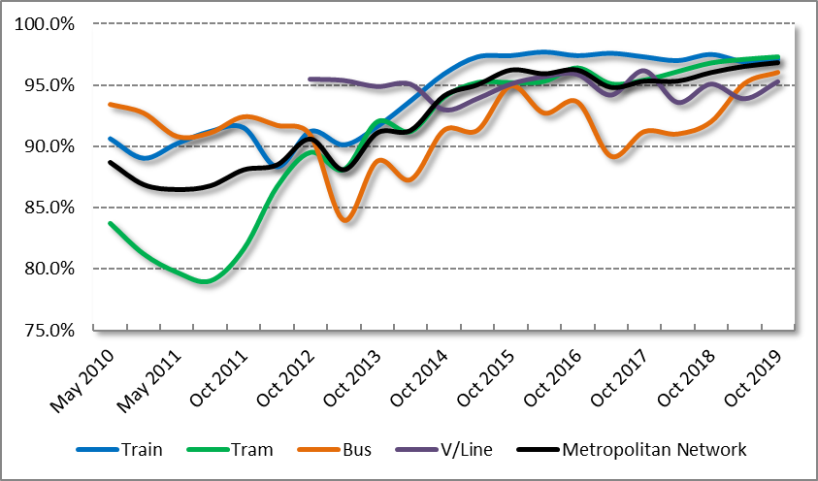

2.3 Revenue impact of fare evasion
The loss of farebox revenue during the 2019 calendar year is estimated at $30.7 million ($25.2 million on the metropolitan network, $5.4 million on regional trains). This is $8.2 million lower than the estimated revenue loss for the 2018 calendar year. Over the same period the overall farebox has continued to grow mainly due to fare changes. Because these changes also affect the estimated loss of farebox revenue, the reduction in estimated revenue loss is made more significant.

2.4 A collaborative approach
DoT, public transport operators and BusVic have developed a collaborative approach to managing the shared challenges of fare compliance across the public transport network. This has promoted innovation and flexibility, which has contributed to improved fare compliance and a more consistent experience for passengers.
Metro Trains and Yarra Trams hold revenue risk via a sharing arrangement for total metropolitan farebox revenue. Accordingly, these operators have a financial incentive to attract more passengers and increase fare compliance on all modes across the network, not just their own services.

2.5 Ticketing Compliance and Enforcement reforms
In 2016, the Government commenced implementation of the Ticketing Compliance and Enforcement reforms (TCE), following the release of the DoT (formerly DEDJTR) Ticketing Compliance and Enforcement Review and the Victorian Ombudsman’s Investigation into public transport fare evasion enforcement. (These reports can be accessed on the DoT and Victorian Ombudsman’s websites.) The TCE reforms aimed to strike a better balance between efficiency and fairness in ticketing compliance and enforcement by focusing enforcement activity towards deliberate and recidivist fare evasion and more systematic discretion and use of official warnings in cases of inadvertent non-compliance.
Significant reforms that have been completed include:
- removing penalty fares and moving to a single infringement system that is fairer and clearer for passengers
- undertaking and promoting ticketing and system improvements to make the myki system easier to use
- embedding systematic use of official warnings under specific conditions
- completing updated conflict management training and a program of refresher training for all AOs
- completing updated training on the use of discretion relating to Special Circumstances including homelessness, and embedding a program of refresher training for all AOs
- reviewing and reaccrediting the Certificate III in Public Transport Customer Service and Compliance for Authorised Officers, the course that all AOs are required to complete before they are authorised by DoT
- increasing the maximum court penalty for ticketing offences to deter recidivist offenders from attempting to game the system
- Increased passenger engagement activities from operators such as AO Community Education events and MTM Passenger Engagement Mornings.
Since the introduction of these reforms and programs, a range of indicators are showing improved perceptions of AOs. This includes a substantial reduction in the number of infringement and AO related approaches to the Public Transport Ombudsman (PTO).
Similarly, PTV’s Customer Satisfaction Monitor (CSM) survey showed steady or improving customer satisfaction with AO results for metropolitan train, tram and bus (see Table 1 below). The V/Line CSM does not measure satisfaction with AOs.
Table 1: Overall Satisfaction with Authorised Officers by Financial Year - Customer Satisfaction Monitor
Public Transport Mode | 2014/15 | 2015/16 | 2016/17 | 2017/18 | 2018/19 | 1st Quarter 2019/20
Metropolitan Train | 73.6 | 73.6 | 74.3 | 77.5 | 79.2 | 78.5
Metropolitan Tram | 69.8 | 70.4 | 70.2 | 73.4 | 74.5 | 74.4
Metropolitan Bus | 76.6 | 75.8 | 78.3 | 79.4 | 82.9 | 80.5

Over the last five years, customer satisfaction with AOs has increased between 4.7 and 6.3 points on all three metropolitan modes. An area of focus for 2020 is to undertake activities that will result in a continuation of this trend.
Over the same period, changes to DoT processes have meant that a significantly higher proportion of Reports of Non-Compliance (RONCs) result in official warnings rather than fines. Changes to DoT prosecutions processes have also resulted in a substantial reduction in the number of court cases involving public transport infringements and the department no longer prosecuting cases where there is evidence of special circumstances.
This plan also acknowledges that, in recent years, operators have continued working on improving passenger experience through initiatives including updated staff training, customer engagement shifts, and the recruitment of AOs from a broad range of backgrounds and experience. Improving passenger experience is embedded in the new metropolitan train and tram contracts which is continuing to show positive results and will be further developed during 2020.

2.6 Additional Authorised Officers
The 2019/20 State Budget included funding for ten additional AOs to be recruited each year for 10 years, resulting in a total of 100 new AOs on the network. These additional AOs will provide an important increase in capacity to support the projected growth in public transport use.
In 2019/20, the initial tranche of additional AOs have been allocated to V/Line (5) and Multi Modal Authorised Officer (MMAO) (5).
In 2020/21 the 10 additional AOs will be employed as:
- 3 Metro Trains Melbourne
- 4 Yarra Trams
- 1 V/Line
- 2 MMAO (focusing primarily on metropolitan and regional bus).
This distribution has been based on consideration of a range of factors including patronage, fare compliance rate, existing staff on the network, along with special events, planned and unplanned disruptions requiring AO support.
2.7 Overview of 2019 NRPP activities
It is possible that the positive fare compliance and customer satisfaction results observed in 2019 can be linked to 2019 ticketing and revenue protection activities aligned with the four revenue protection themes.
- Making the ticketing system easier to use:
- Mobile myki was launched on Android phones on the 28th of March and has already seen more than 220,000 sales (as at December 2019). There are early indications that passengers using Mobile myki are more likely to be ticket ready.
- 100 Quick Top Up Enquiry Machines (QTEM) have now been installed across busy locations on the network. These machines are providing greater convenience for passengers and reducing the time taken to top up a myki.
- PTV’s new website was introduced in 2019 and saw the introduction of a fare estimate on the website’s journey planner. This represents a substantial enhancement in a passenger’s access to fare information. Further website enhancements that include integration of myki ticketing are planned for later in 2019 and early in 2020.
- Compliance Support:
- Bus operators have continued to improve their performance in ensuring ticketing devices are operational. This ensures more passengers are able to top up or purchase a myki onboard buses where required.
- Ticket checking:
- DoT and operators are continuing to strategically deploy AOs using data such as the Fare Compliance Surveys to normalise fare compliance. In addition, AOs are being increasingly deployed to provide passenger support during special events as well as planned and unplanned disruptions.
- Joint operations between AOs and VicPol have increased in 2019 at key transport interchanges. These operations deter antisocial behaviour and target deliberate recidivist fare evaders.
- More AOs are now commencing their shifts ‘on network’ from satellite depots, which is reducing travel time and improving the ability to check more tickets where and when it is most needed.
- Marketing and education:
- Two marketing campaigns in the first half of 2019 promoted the use of Mobile myki and QTEMs. These campaigns have resulted in positive customer perception and strong passenger awareness, particularly for Mobile myki.
- Operators have continued to build on their community education activities, which include AOs giving presentations to schools and engaging with passengers in a non-enforcement capacity to positively influence fare compliance.

3 FARE COMPLIANCE STRATEGY
3.1 Revenue protection themes
The complexity of fare evasion behaviour means that a range of actions are required for effective revenue protection.
The approach used by DoT and public transport operators is based on the following four themes:
- making the ticketing system easier to use: continuous improvement to the ticketing system to make it easier to use, access and understand, with the aim of improving the passenger experience
- compliance support: employees at stations and on the tram and bus network, ticket barriers at railway stations
- ticket checking: activities by AOs, including reporting non-compliance
- marketing and education: customer information campaigns to help passengers be ready to travel and use high readiness products, as well as making it easier to use myki by continually improving education on how to use the ticketing system.
Figure 2: Four themes of revenue protection
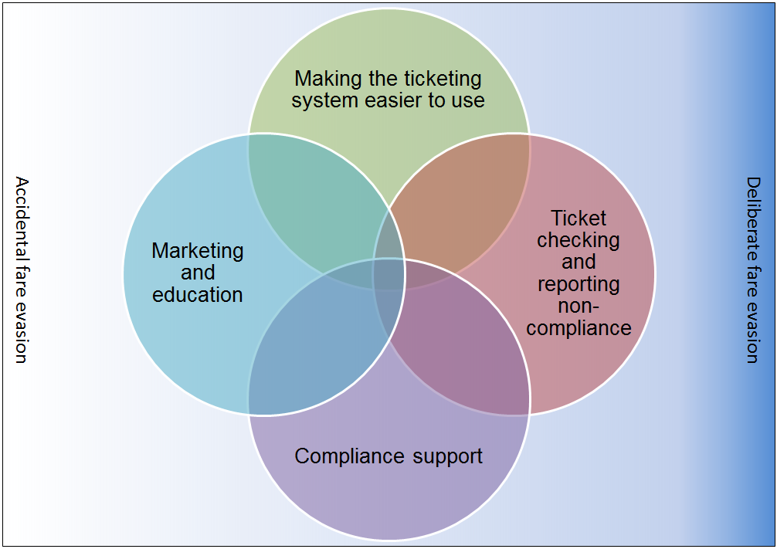

Each of the above themes in Figure 2 is important but none is sufficient on its own. Together, they support a suite of revenue protection measures that aim to make it easy for passengers to do the right thing and harder to deliberately and repeatedly fare evade. Moreover, the culture of fare compliance extends to public transport staff as well. This includes all frontline transport staff – such as bus drivers, V/Line Conductors and railway station staff – understanding the role they each play in supporting revenue protection.
The aim of this approach is to encourage passengers to see travelling with valid tickets as the norm while, at the same time, providing better information to improve the passenger experience and reduce the likelihood of inadvertent fare evasion.
Staff presence on the network along with ticket checking by AOs and V/Line train Conductors are important to remind passengers of the need to travel with a valid ticket. Between May 2010 and May 2015, metropolitan data has shown a strong relationship between the fare compliance rate and the number of tickets checked (see Figure 3). The deviation between the two lines since November 2015 is in part due to AOs focusing on revenue protection through more customer education and support activities while continuing to maintain a visible presence on the network. Ticketing infrastructure improvements such as the continued rollout of next generation Fare Payment Devices (FPD) and ticket barriers at new and reconstructed stations are also factors.

Figure 3: Fare compliance and tickets checked – May 2013 to October 2019
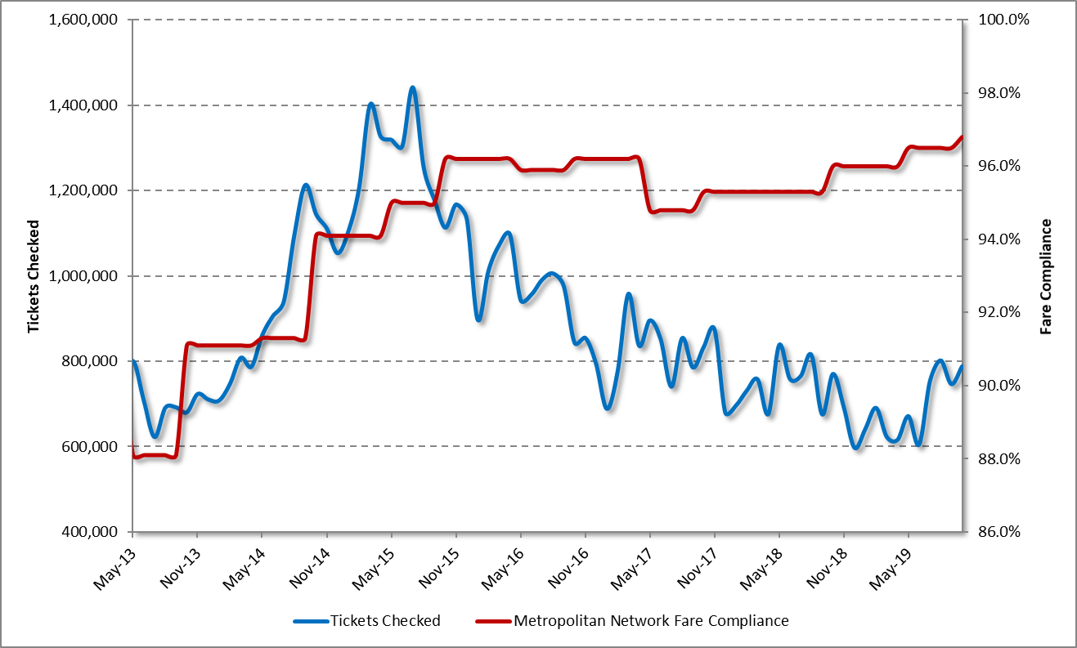
Marketing campaigns have supported a behavioural insights approach to fare compliance by raising awareness of high readiness myki products such as Auto Top-Up and myki Pass. Research indicated that many passengers were unaware of these products or needed additional information about them. Data collected during 2018 shows that there has been a small but steady increase in the use of Auto Top-Up following a campaign to raise awareness.
System support mechanisms also contribute to improved fare compliance across the network with the benefits being broader than individual modes. For example, ticket barriers at major train stations can help protect revenue on trams and buses. The majority of metropolitan Melbourne train passengers begin or end their train journey at a gated station, creating an incentive for them to travel with a valid ticket. This benefit extends to buses and trams because many passengers use multiple modes to complete their journeys.
Under this approach, fare compliance has remained at a high level and continuing this is the aim of the 2019 revenue protection actions.
3.2 Responsibility for maximising fare compliance
Operators are required to meet a number of contractual obligations under their Agreements with DoT. While the conditions vary between operators, some key elements are:
- using reasonable endeavours to ensure passengers have valid tickets (including eligibility for concessions)
- employing and deploying agreed numbers of AOs
- working with DoT to develop, implement and comply with a Network Revenue Protection Plan
- maintaining accurate records and providing reports to DoT on revenue protection measures.
- managing customer service staff to maximise fare compliance, (e.g. through staffing ticket barriers at stations, providing information at tram and bus stops)
- supporting the conduct of the fare compliance survey through commitment of AOs and in the case of V/Line, train Conductors
- providing timely and accurate metrics to support monitoring of revenue protection activities.
DoT is responsible for:
- strategic public transport policy in relation to fares, ticketing, compliance and enforcement
- setting the strategic framework for revenue protection
- regulatory and legislative change relating to enforcement
- issuing and processing ticket infringement notices
- promoting innovation and overseeing specific initiatives to lead the industry
- managing updates to the ticketing conditions and new policy
- developing and undertaking marketing and information campaigns
- overseeing the operation and continued development of the myki system
- monitoring operator performance in line with contractual arrangements
- accrediting and regulating AOs to ensure they have the authorisation required to undertake their duties.
- undertaking regular fare compliance surveys, sharing the results with operators and publishing overall results in a timely fashion
- developing overall strategy and deployment plans for Multi-Modal Authorised Officers (MMAO) and ensuring implementation of the plan
The Revenue Protection Plan Implementation Committee is responsible for delivery of the initiatives contained in this plan. Members of this group represent:
- Department of Transport
- Metro Trains Melbourne
- Yarra Trams
- Bus Association Victoria
- Ventura
- Transdev
- V/Line.
This group will continue to meet every second month, with revenue protection meetings being held with individual modes in the intervening months.

4 2020 REVENUE PROTECTION PRIORITIES

As noted in Section 1, two priority areas underpin the initiatives to maintain high fare compliance levels in 2020. These are discussed in more detail below.

4.1 Undertake revenue protection activities in a way that improves passenger experience (continuing priority from previous plans)

4.1.1 Context
As outlined in section 2.5, the TCE reforms have resulted in significant improvements in customer experience with AOs on the public transport network. This has been demonstrated by a continued increase in customer satisfaction results, along with a reduction in complaints about AOs and infringements being received by PTV and the PTO.
- The importance of the passenger experience has been further highlighted within the new contracts for train, tram and bus, and the V/Line partnership agreement.
- Changes to the myki system have also supported improved fare compliance through measures including: the introduction of Mobile myki for Android smartphones, accelerating the program to install new faster myki readers on the train, tram and bus networks and installing more than 100 Quick Top Up Machines (QTEMS) at key locations across the network. A continuation of these activities is planned for 2020.
- Supporting passengers to travel with a valid ticket during periods of network disruption will continue to be a challenge throughout 2020 as Victoria’s big build continues.
- DoT, operators and BusVic will continue the approach of working together to further improve customer experience by providing better information and support to passengers so that it is easier for them to travel with a valid ticket. This will include maintaining a continuous improvement approach to AO practice, making progressive changes to the myki system and providing better information to passengers about planned and unplanned disruptions.

4.1.2 Actions
- Continue to support all frontline staff to provide passengers with an improved end-to-end customer service experience - DoT, metropolitan train, tram, bus, V/Line.
- Continue to improve infringement processes - DoT

4.2 Increased awareness and frequency of myki touch ons

4.2.1 Context
Fare compliance across the myki network has remained high over recent years, but there continue to be gaps between the number of passengers using public transport and the number of myki touch ons.
Research into touch on behaviour has identified that passengers don't touch on for a range of reasons, including deliberate fare evasion, lack of understanding or pressure to board the bus or tram quickly
While many passengers who don’t touch on will still be travelling with a valid ticket (either an active myki Pass, or a ‘touched on’ myki from a previous mode), improving the frequency of myki touch ons is important as it:
- ensures more accurate data is collected on where/when passengers are using the network to improve network planning
- signals the correct ticketing behaviour to other passengers to normalise touch ons and improve fare compliance.

4.2.2 Actions
- Develop and deliver marketing and on-system messaging to improve the rate of touch ons - DoT, metropolitan train, tram, bus, V/Line.

5 Other Actions Aligned with The Four Themes Of Revenue Protection
In addition to the activities associated with the two priority areas, the following actions will be delivered by DoT, BusVic and public transport operators during 2020. Actions have been categorised according to the strategic elements identified in Section 3.

5.1 Making the ticketing system easier to use
- Oversee the operation and continued development of the myki system – DoT
- Continue to make the myki system easier to use through progressive improvements - DoT

5.2 Compliance support
- Communicate regularly with staff to remind them of the importance of fare compliance – DoT, metropolitan train, tram, bus, V/Line
- Support bus drivers to encourage passengers to top up and touch on – bus
- Continue to promote driver compliance with correct bus driver console usage and fault reporting – bus
- Continue strategies to support revenue protection activities by V/Line conductors and other staff – DoT, V/Line
- Continue to staff and close wide ticket barriers at gated stations in line with contractual arrangements – metropolitan trains, V/Line.

5.3 Ticket checking and Reports of Non-Compliance
- Deploy AOs strategically, using survey and other data, to a combination of high value areas and general network coverage to normalise fare compliance – DoT, metropolitan train, tram, bus, V/Line
- Continue to increase the visibility of AOs across the public transport network - DoT, metropolitan train, tram, bus, V/Line

5.4 Marketing and education campaigns
- Develop and deliver on-system messaging to encourage passengers to travel with a valid ticket at all times and build better understand of the ticketing system – DoT
- Give presentations at schools and universities, as required, to educate students on behavioural requirements and the need to have a valid ticket – metropolitan train, tram, bus, V/Line.
- Improve promotion of high readiness ticketing products by AOs, V/Line train Conductors and frontline staff – DoT, metropolitan train, tram, bus, V/Line.

6 MEASUREMENT AND MONITORING

6.1 Revenue protection key performance indicators
DoT and operators work together to establish a consistent set of metrics that can be monitored to assess the effectiveness of revenue protection activities. These indicators are aligned with the TCE reforms and reflect the breadth of revenue protection activities, including:
- Fare Compliance Survey results
- Touch on rate survey
- Customer satisfaction with AOs
- Customer satisfaction with the myki ticketing system
- Proportion of passengers using ‘high readiness’ ticketing products
Revenue protection metrics are regularly reviewed to ensure they remain relevant and changes are made where improvements are identified, or different metrics are required.
Operators also use a range of metrics for planning and monitoring their own revenue protection activities. They work with DoT to coordinate activities and monitor revenue protection trends across the network
As in previous years, DoT and operators will share relevant data and prepare specific reports to inform the development and implementation of revenue protection activities.

