Extra bus services and simpler routes for the Macedon Ranges

October 2018

We’re splitting the current Lancefield to Kyneton via Sunbury bus service into three distinct routes and adding extra trips to give you a bus network that’s easier to understand and use.
Read about the proposed changes below.

Route and destinations
We’re proposing to introduce three distinct routes to simplify the Macedon Ranges bus network and improve your travel experience. The three routes will be:
Romsey to Kyneton
Lancefield to Sunbury
Lancefield to Gisborne

More weekday services for Romsey to Kyneton
We’re introducing extra services on the Romsey to Kyneton route to provide you with a more consistent weekday timetable. The new timetable will provide you with two return services per day, Monday to Saturday. The service will operate Romsey to Kyneton via Lancefield and Newham.

More weekday services for Lancefield to Gisborne
We’re introducing extra services on the Lancefield to Gisborne route to provide you with a more consistent weekday timetable and more travel options. The new timetable will provide you with two return services per day, Monday to Saturday.

More weekday services for Lancefield to Sunbury
We’re introducing extra return services for the Lancefield to Sunbury bus to improve connections with trains and give you more travel options. Your new timetable will provide twelve return trips per day Monday to Friday, and three return trips on Saturdays.

Span of hours
Timetables for your new services are being developed, however it is expected the span of hours will be approximately as follows.

Romsey to Kyneton
Weekdays – 9am to 2.30pm
Saturday – 10.30am to 12.30pm

Lancefield to Sunbury
Weekdays – 6.20am to 8pm
Saturday – 8am to 6.30pm

Lancefield to Gisborne
Weekdays – 9.30am to 2pm
Saturday – 11am to 4.30pm

Next steps
Timetables for your new bus services are being developed as we prepare to introduce your new, simpler bus network. Travel information will be available on the PTV website one month before the changes begin.
To plan your journey visit ptv.vic.gov.au

Proposed route and destinations
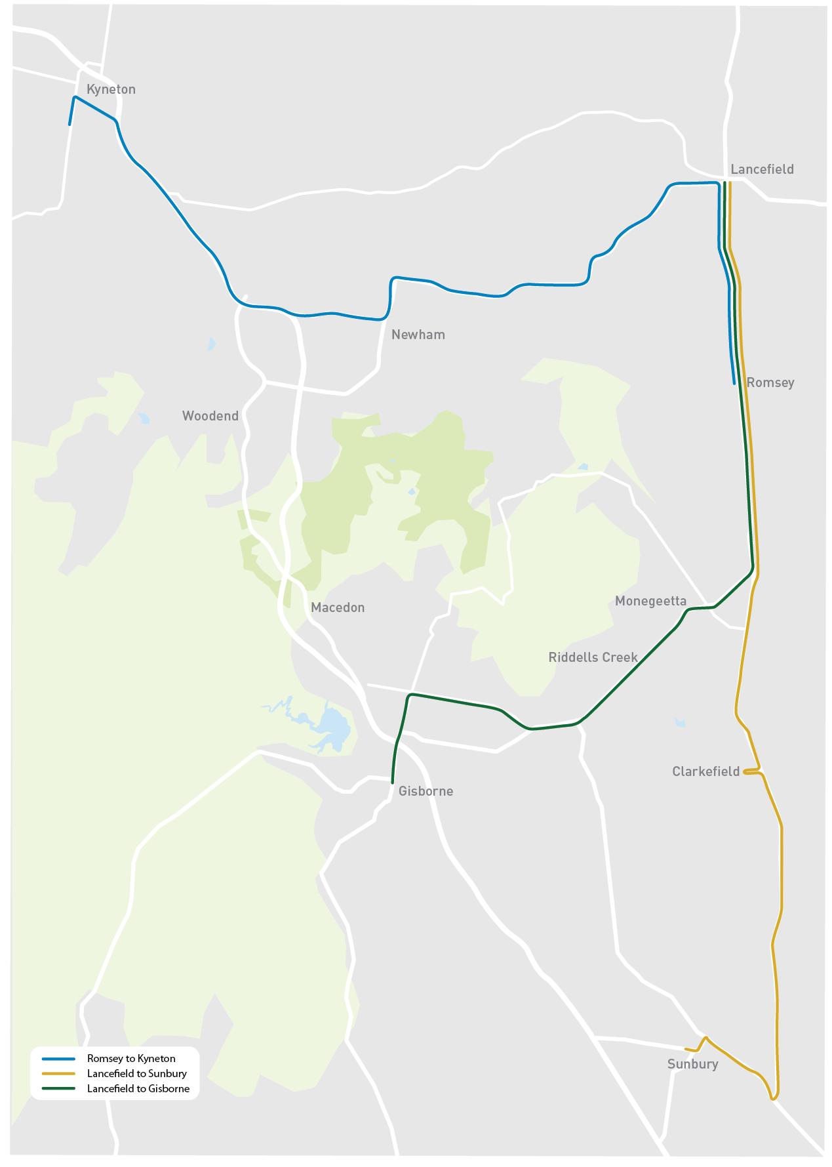
To plan your journey visit ptv.vic.gov.au or call 1800 800 007.
Authorised by Transport for Victoria, 1 Spring Street, Melbourne.

